**SPRINT 3 PLAN**

Project Name: Boba Tracker

Team Name: Boba Peeps

**GOALS:**

Now that the frontend and backend are integrated, the goal now is to ensure the app supports independent user data, and make it look nicer

**TASKS**

User story 1: As a user, I want to view my information in a chart. (8 Story Points)

* Display chart with correct data
  + Time estimate: 1-2 hrs

User story 2: As a user, I want my data stored securely and independently in a database (13 Story Points)

* Add User ID column to entries database
  + Time estimate 1 hour
* Map User ID to drink post/get requests to separate users
  + Time estimate 2 hours

User story 3: As a user, I want to be able to view my purchase history.

* Add an editing button for each entry.
  + Time estimate: 2 hours
* Add a delete button for each entry.
  + Time estimate: 2 hours

**TEAM ROLES**

* Jarod Alvarez: Product Owner
* Maggie Lee: Developer
* Johana Martinez: Developer
* Thai Nguyen: Scrum Master
* Chi Huynh: Developer

**INITIAL TASK ASSIGNMENT**

* Jarod Alvarez
  + User story: 2
  + Initial Task: Add user id column to database and create needed routes in API
* Maggie Lee
  + User story: 1
  + Initial Task: Include user ID in GET request to get specific user’s data
* Johana Martinez
  + User story: 2
  + Initial Task: Map User ID to drink post requests to separate users
* Thai Nguyen
  + User story: 4
  + Initial Task: Change error messages when signing in
* Chi Huynh
  + User story: 3
  + Initial Task: Add delete & modify feature to history

**INITIAL SCRUM BOARD**

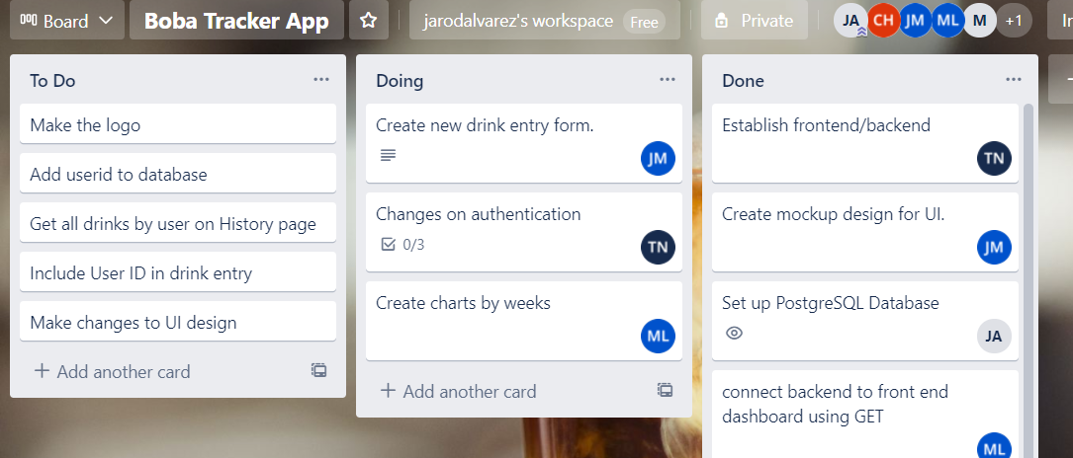

**BURNUP CHART**

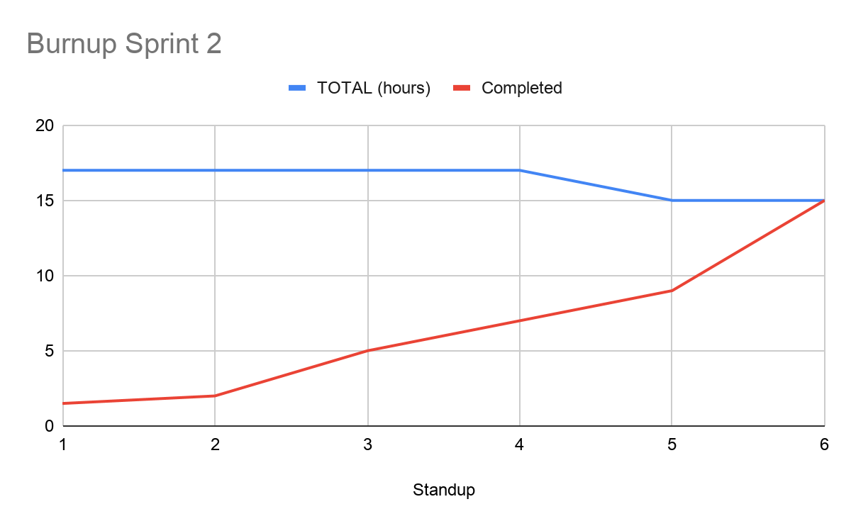

**SCRUM TIMES**

* **MWF - 7pm PST** (Team Stand Up)
* **Wed - 10:30 PST** (Weekly TA Stand Up)